Ideation Phase
Brainstorm & Idea Prioritization Template
Date | 19 Jul 2026
Team ID
Project Name | AI-powered Job Recruitment & Candidate Management System
Maximum Marks | 4 Marks

Reference: https://www.mural.co/templates/brainstorm-and-idea-prioritization
Step-1: Team Gathering, Collaboration and Select the Problem Statement
The project team conducted a brainstorming session to identify real-world problems that could be solved using Salesforce CRM and Artificial Intelligence. Various domains such as healthcare, education, inventory management, customer support, and recruitment were discussed.
After evaluating the feasibility, impact, scalability, and relevance to Salesforce technologies, the team selected the problem of inefficient recruitment and candidate management. Traditional recruitment processes involve manual resume screening, interview scheduling, candidate tracking, and approval workflows, which consume significant time and resources.
The team agreed to develop an AI-Powered Job Recruitment & Candidate Management System that automates recruitment activities, centralizes candidate information, assists recruiters with AI-generated insights, and improves hiring efficiency using Salesforce CRM and Agentforce.

Step-2: Brainstorm, Idea Listing and Grouping
Brainstormed Ideas
Idea No. | Proposed Idea | Category
1 | AI-Powered Job Recruitment & Candidate Management System | Human Resources
2 | Hospital Patient Management System | Healthcare
3 | Smart Inventory Management System | Business
4 | Student Performance Analytics Portal | Education
5 | AI-Based Customer Support System | Customer Service
6 | Employee Leave Management System | Human Resources
7 | Online Complaint Management Portal | Public Services
8 | Smart Event Registration System | Event Management

Grouping of Ideas
Human Resources
- AI Recruitment System
- Employee Leave Management
Healthcare
- Hospital Patient Management
Education
- Student Performance Analytics
Business
- Inventory Management
Customer Service
- AI Customer Support
Public Services
- Complaint Management
Event Management
- Event Registration System
Step-3: Idea Prioritization
The team evaluated each idea based on the following criteria:
- Real-world impact
- Innovation
- Feasibility using Salesforce
- AI integration capability
- Automation potential
- Ease of implementation
- Future scalability

Idea | Innovation | Feasibility | AI Integration | Overall Priority
AI-Powered Job Recruitment & Candidate Management System | High | High | High | 1
Hospital Patient Management | High | Medium | Medium | 2
Smart Inventory Management | Medium | High | Low | 3
Student Performance Analytics | Medium | Medium | Medium | 4
AI Customer Support | High | Medium | High | 5

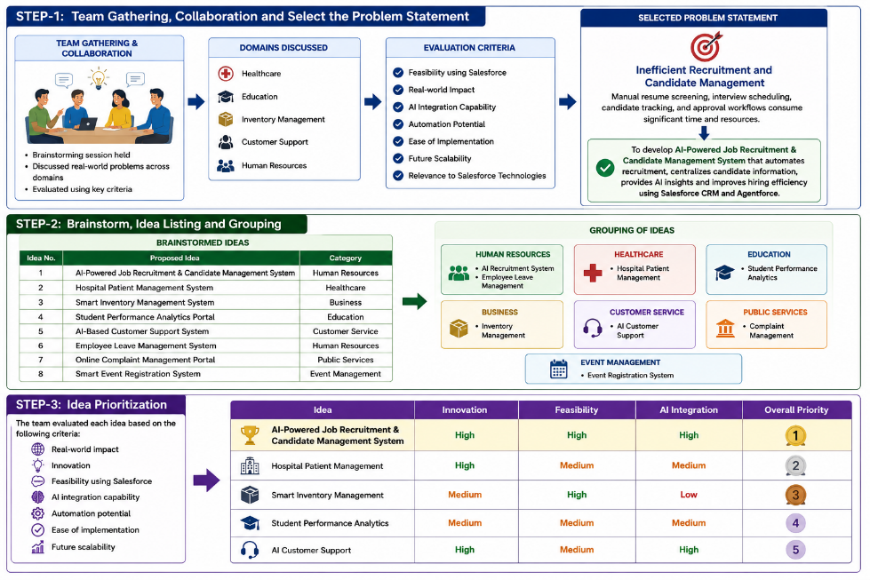
Final Selected Idea
AI-Powered Job Recruitment & Candidate Management System
Reason for Selection
The team selected this project because recruitment is a critical business process that can benefit significantly from automation and artificial intelligence. The proposed system streamlines the entire hiring lifecycle by managing job openings, candidate applications, interview scheduling, approval workflows, and hiring decisions within Salesforce CRM. AI capabilities such as candidate evaluation, hiring risk analysis, and intelligent recommendations help recruiters make faster and more informed decisions. The solution is scalable, improves productivity, reduces manual effort, and provides an enhanced recruitment experience for both recruiters and candidates.

